Docker Task -1

Task Description:
Install docker on EC2 and explore the docker commands (docker images, containers, volumes, network)
Created ubuntu machine: 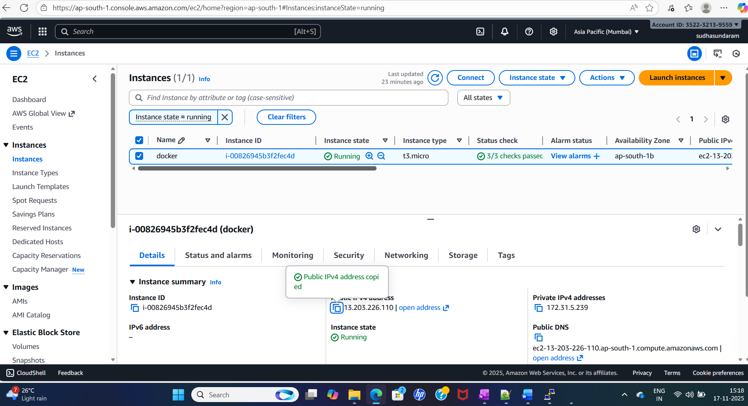
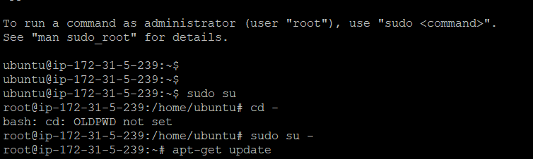
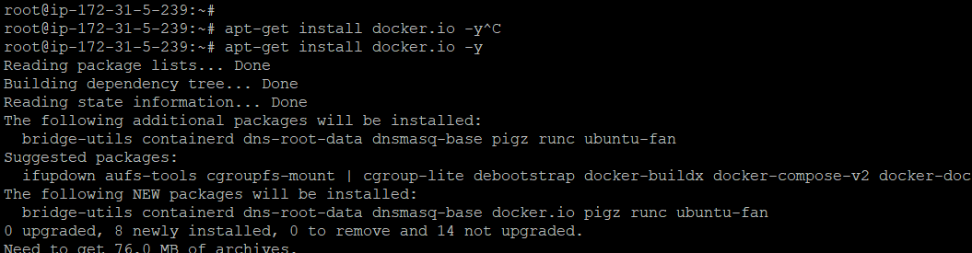
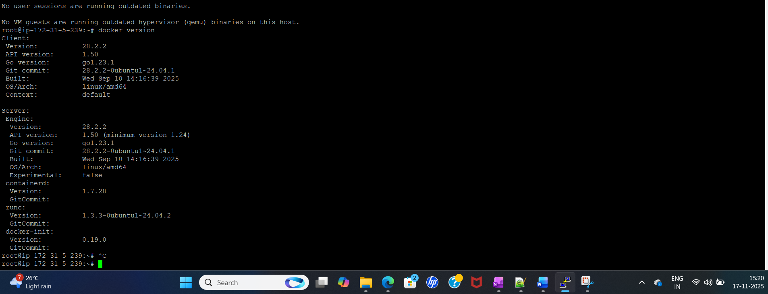

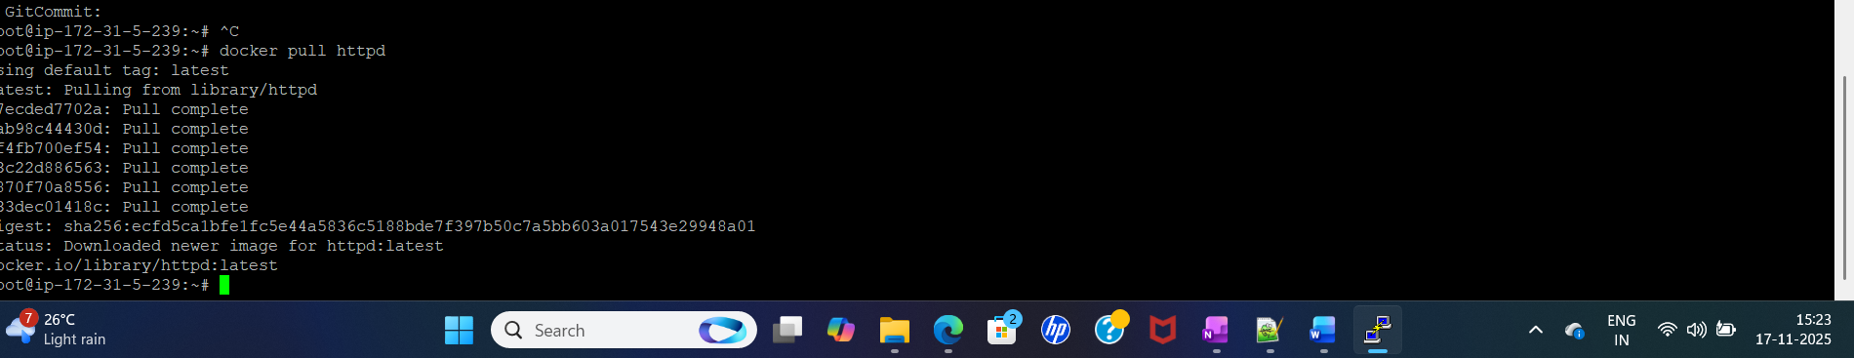

In order to confirm the images is pulled or not:
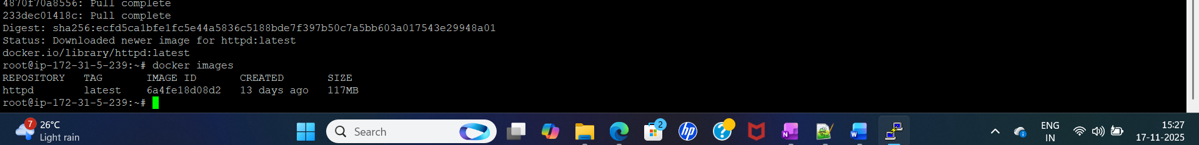
Docker run – bringing the container.
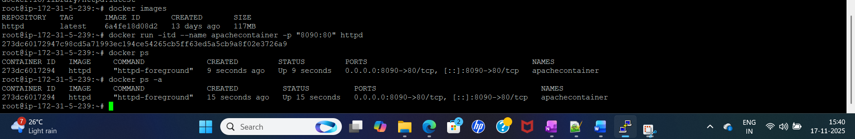

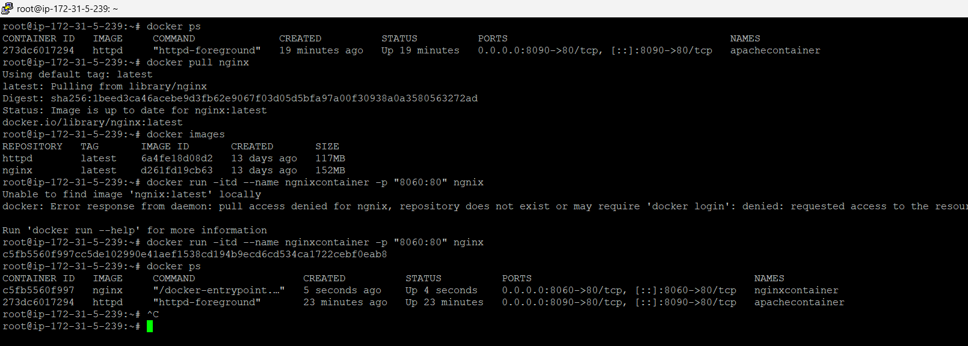
Stop the container and remove the container.
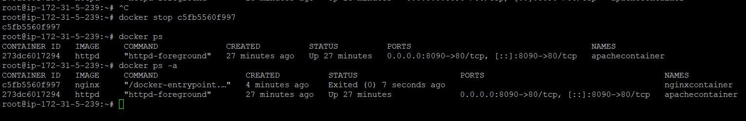

Remove the image
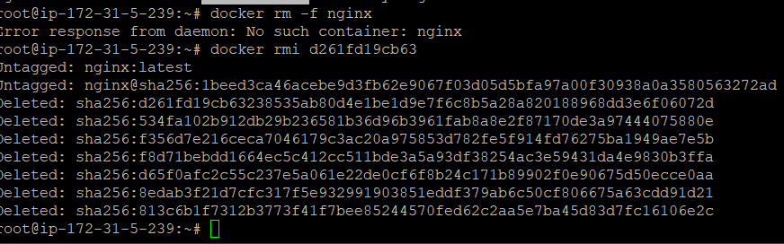
I have deleted nginx image, but try to bring the nginx container.

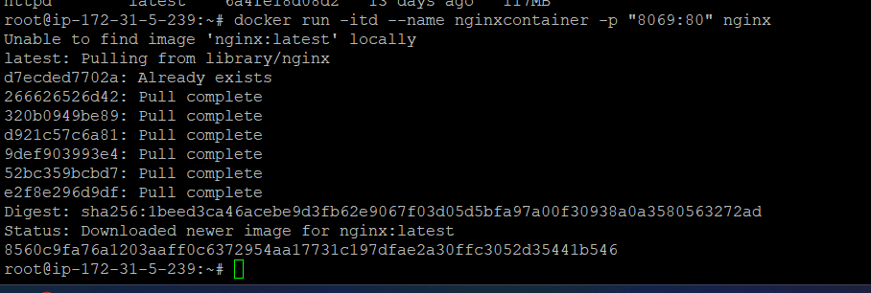
Check the process utilization
Go to Inside the container use exec command
Execute/exit

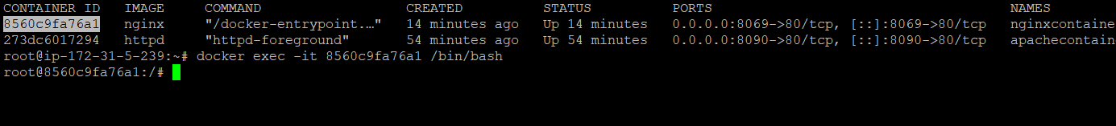
Checking container logs
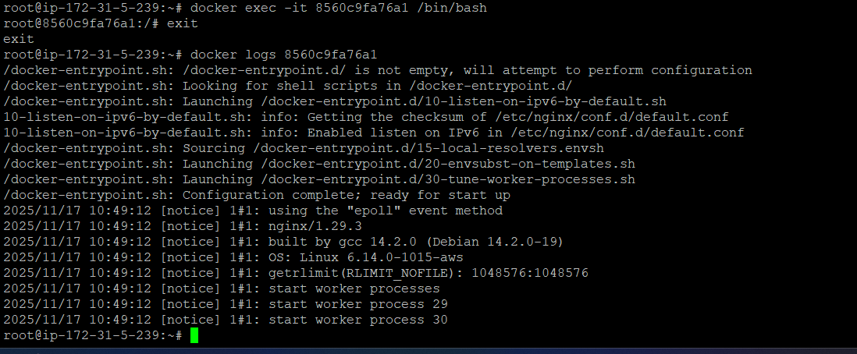

Overeall information about the container: Volume, network and other details can get it by using inspect.
inspect command:
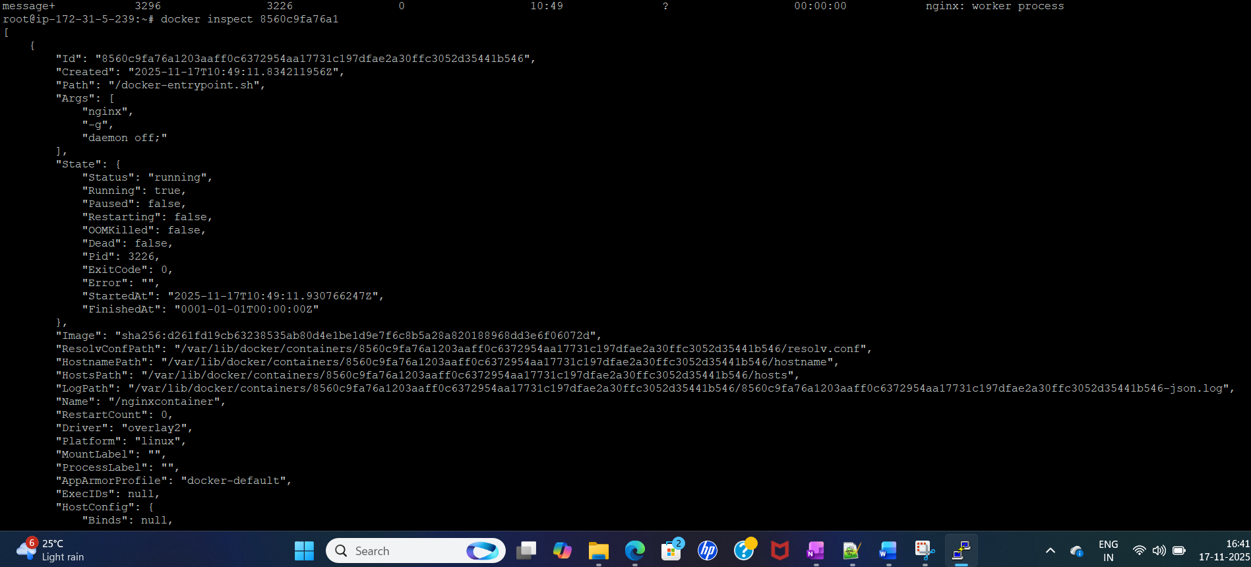

About docker info:

